**SYSTEM INSTALLATION**

**GUIDE (64 bits)**



1. Download MS VC Packages Zip File using this link:

<https://wampserver.aviatechno.net/files/vcpackages/all_vc_redist_x86_x64.zip>

3.1 Download winrar exe by using this link and install it:

<https://www.win-rar.com/fileadmin/winrar-versions/winrar/winrar-x64-624.exe>

3.2 Right Click the MS VC Packages Zip and click Extract Here to extract the file

3.3 Install all files inside the package

2. Download wamp server exe by using this link:

<https://wampserver.aviatechno.net/files/install/wampserver3.3.0_x64.exe>

2.1 Install it after downloaded

3. Download wamp server updater by using this link:

<https://wampserver.aviatechno.net/files/updates/wampserver3_x86_x64_update3.3.1.exe>

3.1 Install it after downloaded

4. Download phpmyadmin by using this link:

<https://wampserver.aviatechno.net/files/apps/wampserver3_x86_x64_phpmyadmin5.2.0.exe>

4.1 Install it after downloaded

5. Download php by using this link:

<https://wampserver.aviatechno.net/files/php/wampserver3_x64_addon_php7.3.33.exe>

5.1 Install it after downloaded

6. Download MYSQL by using this link:

<https://wampserver.aviatechno.net/files/mysql/wampserver3_x64_addon_mysql8.0.31.exe>

6.1 Install it after downloaded

7. Download MariaDB by using this link:

<https://wampserver.aviatechno.net/files/mariadb/wampserver3_x64_addon_mariadb10.10.2.exe>

7.1 Install it after downloaded

8. Start the wamp server

8.1 We can see the wamp server icon shown in the picture below

**Wamp Server Installation**

9. Download composer by using this link:

<https://getcomposer.org/Composer-Setup.exe>

9.1 Install it after donwloaded

10. Download and install VS Code by using this link:

<https://code.visualstudio.com/sha/download?build=stable&os=win32-x64-user>

10.1 Install it after downloaded

12. Go to this directory path in your File Explorer:

C:\wamp64\www

13. Copy & Paste (CTRL + C & CTRL +V) / CUT(CTRL + X) the zip file project and place it inside the www directory

14. Extract the zip file project. If the zip has a password, it means you’re not paid yet. The password will give as long as you have been paid of the amount of the system project.

15. Once already extracted, open it in the VS Code. Follow the pictures that shown below:

**Right Click in phpmyadmin, php, MySQL, and MariaDB to select the version**

**Right Click**

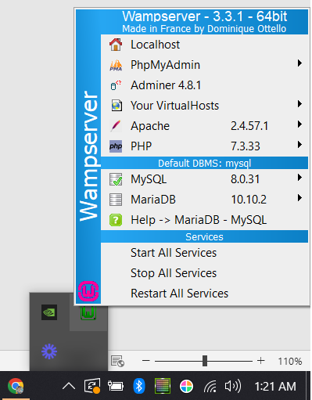

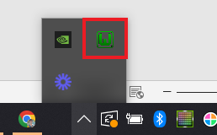

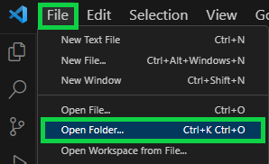

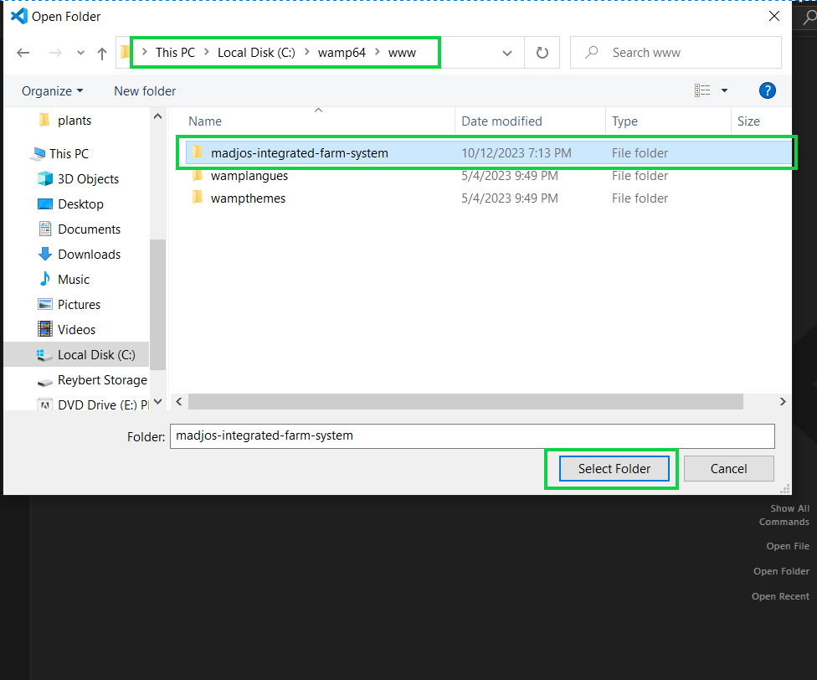

16. Go to this url to setup the database:

<http://localhost/phpmyadmin>

17. Open the VS Code terminal using this shortcut key **CTRL + `** then run the below commands:

17.1 php artisan view:clear

17.2 php artisan config:clear

17.3 php artisan config:cache

17.4 php artisan cache:clear

17.5 composer dump-autoload

17.6 php artisan key:generate

17.7 php artisan

18. Then, go to your browser and paste this url:

<http://localhost/madjos-integrated-farm-system/public/>

